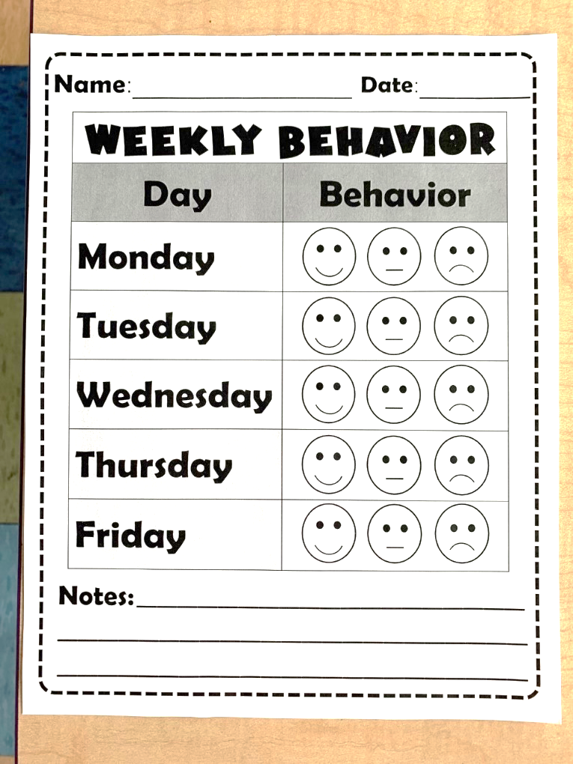

In addition to our Behavior Buddies this year, a weekly behavior chart will be sent home in Take-Home Folders. This sheet will entail the days of the week, 3 different behavior faces next to each day, and a notes section.

This weekly chart will need to be kept in your child’s Take-Home Folder and brought to class throughout the week. At the end of each day, a behavior face will be filled in that reflects what the student’s behavior was for that day. If students have earned happy or neutral faces all week, they will receive a treasure from our class prize box at the end of the week as an incentive for great behavior. A new chart will be placed in students’ folders at the start of each week.

A sad face may be filled in at the end of class if a student displayed harsh or destructive behavior in the classroom throughout the day.

A neutral face may be filled in at the end of class if a student required multiple reminders, struggled with listening ears, etc. throughout the day.

Teachers may write any notes to parents here reflecting their child’s behavior for that day.

A happy face may be filled in at the end of class for displaying great behavior throughout the day.

Weekly Behavior Chart