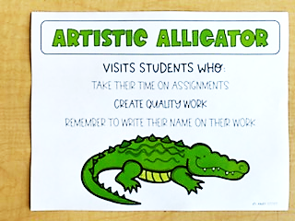

This year, our classroom will be using Behavior Buddies to promote positive behavior with stuffed animals. Each animal will represent different types of positive behaviors that students are encouraged to do.

These Behavior Buddies can be earned when students are showing great behavior in the classroom! At the end of each day, students that have demonstrated positive behaviors in the classroom will be chosen and will then get to spend their next school day with that Buddy. Their furry friend will get to stay with them throughout the day in our classroom! A certificate will also be sent home in their Take Home Folder for parents to see.

Behavior Buddies